Current Market View – October 2025

Investment Markets
Global Markets
Global markets continued their positive trend, rising for most developed regions in October 2025. Investors have discounted the impact of inflation and interest rates on asset prices and continue to add to their "risk-on" positions. Equity investors appreciated the interest rate cut in the US, amid signs of a slowing labour market and continued pressure on consumer prices, marking the second rate cut in 2025. This led to the resumption of the "buy the dip" mentality that had been prevalent in recent times.

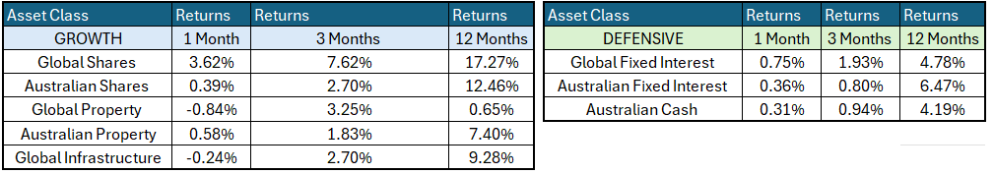

The Federal Reserve Bank (the Fed) remains focused on the inflationary impact of the tariffs; however, the economy is performing well, with limited inflationary impact from the introduction of US tariffs to date.
Global Share Markets
Following an interest cut during the October FOMC meeting, US share markets are factoring in another 25-basis-point cut in the Federal Funds target cash rate for the next FOMC meeting, due to start on the 9th / 10th of December 2025. The Global Markets were mostly positive in October 2025. Japan shot to the lead in October, following the election of its new Prime Minister, who is believed to be very business-friendly, which saw Softbank's stock rise 45% over the month.
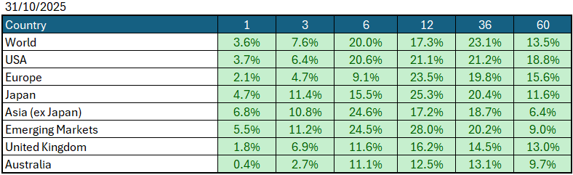
Data Source: AFM as of October 31 2025.
Global Bond Markets
Bond markets remain unconvinced by the tariff reprieve, believing that the outcome will ultimately lead to further inflation. However, global central bank bias towards lower interest rates is leading the path forward, with yields retreating ahead of the next US FOMC meeting. The long end of the interest rate curve is sensitive; however, it managed to trade lower in yield terms, reflecting the expected 25-basis-point shift in December.
Interest rate markets in the US eased over the month of October 2025, with the 10-year Government bonds falling to 4.11%. UK 10-year Gilts were trading at 4.506% on October 30 2025.
Domestic Bond Markets
For Australia, the latest inflation prints for (year-on-year) September 2025 increased to 3.2% which was an increase from 3.0% in August 2025. The RBA board meeting held on 3rd/4th November 2025 saw the target cash rate held steady at 3.60%, a continuation from the September meeting. The next RBA Monetary Policy meeting is due on the 8th/9th December 2025.
Investment Climate
Over the month, tariff negotiations between the US and China cooled, with deals struck on fentanyl, soybeans, and rare earths, as well as significantly lower tariffs than Trump had threatened just days before. However, this occurred late into an already strong month. Also going on in the background has been the US federal government shutdown, which began at the start of October. Whilst this sounds like a disaster, it only impacts 25% of government spending, which does not affect social security, Medicare, interest on debts and essential workers, such as hospitals, medical, and air traffic controllers.
Medium-term investors are encouraged by the anticipated gradual easing of interest rates; however, the unsettled nature of the share and bond markets clouds the short-term direction. The soft-landing expectations and economic recovery are still supported by the economic data, despite the recent volatility.
The medium-term view remains positive for returns, as US Fed Chair Jerome Powell appears to have shifted his stance to further easing of interest rates in the US by December 2025. At the 28th/29th October 2025 Meeting, the Fed eased interest rates by 0.25% to 4.00%, with the market anticipating another 0.25% cut at the 9th/10th December 2025 Meeting.
Long-term investors are optimistic about a recovery period ahead. Global central banks continue to indicate a resolve to get inflation under control; however, the economic data is showing signs of stabilisation despite inflation being elevated, and every indication is for future easing in monetary policy to be possible over 2025. Remember, markets are forward-looking, so the support now reflects the expectations for conditions in March 2026.
The following commentary is based on month-end closing prices as of October 30 2025:
Global share markets performed strongly over October, with China being the notable exception, as returns recovered despite the ongoing tariff situation and subsequent bouts of volatility following each tariff announcement. The AUD/USD weakened from 0.6613 to 0.6542 (-1.1%).
The US Fed eased the monetary policy to the target range for federal funds of 3.75%-4.00% when it met on the 28th/29th October 2025. Investors are gaining more confidence that the economy is headed for a soft landing despite the intermittent bouts of volatility. The next Fed meeting is on the 9th / 10th December 2025.
The underlying short-term theme is "risk-on" for shares.
The situation in the Russia/Ukraine conflict remains unchanged ,however, the latest conflict between Israel, Gaza (Hamas) has cooled.
Investor Focus
For Australia, investors focused on the following issues:
- Cost of living expenses and the impact on consumer spending.
- Commodity prices (post-China policy changes) and the impact on company profits.
- The level of interest rates and the delicate position of the RBA, given the global volatility in markets.
- US tariffs and the impact on Australia's exports (if any).
- Inflation (year-over-year) increased to 3.2% in September, with the next quarterly CPI being released on November 26, 2025.
- Government spending and the rising debt level.

Currency
The Australian Dollar closed weaker, AUD/USD 0.6542 at the end of October 2025, down 0.71 cents from 0.6613. This was despite the Fed cutting rates during the month, but it was a positive for returns for investors who held offshore assets unhedged.
Currency forecasters see the AUD/USD range between:
0.5750 and 0.6750 cents in the medium term and most likely to trade within the:
0.5500 to 0.7500 range in the longer term.

Australian Economy
Australia's latest GDP data for the second quarter of 2025 revealed an annual growth rate of 1.8% which was up from 1.3% in the first quarter of 2025. Unemployment rose to 4.5% in September 2025. The year-over-year (Y-O-Y) inflation rate increased to 3.2% in September 2025, up from 3.0% in August 2025, which is now outside the Reserve Bank's targeted 2% to 3% inflation range.

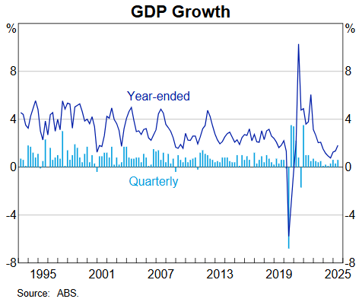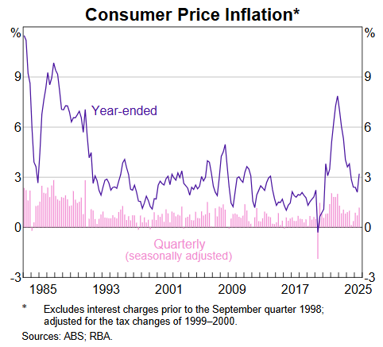

Current Market View

Domestic View
The overall investment view for shares is "risk-on" over the short term, "cautiously optimistic" over the medium term, and "long run" as interest rates are expected to continue trending down following the implementation of tariffs and future anticipated easing of Monetary Policy by the RBA.
The market is expecting no interest rate cuts until the 2nd/3rd of February 2026, due to a "hotter" inflation print in the last week of October that showed inflation is now outside the RBA's target range of 2-3%.

Global View
The global share market remains positive despite the government shutdown, bolstered by positive talks between China and the US, and backed by central banks looking to ease interest rates to prevent further fallout from the events.

Where to From Here?
Tariffs have had a muted impact on our resource sector to date. Although the market initially overreacted on the downside, most of this has been unwound lately.
The company reporting season in August 2025 was solid, and this positive trend has continued into the November reporting season globally, as well as for the Australian bank reporting season. Guidance was met or exceeded in key industries, which will support the positive momentum of the share market.
The Middle East political unrest is a background factor that is not easily solved. Let us hope the situation will be contained and a solution that ceases further aggression and violence is forthcoming.
Markets are forward-looking, so it is likely they have taken a positive view of what lies ahead and started adding to positions ahead of the rest of the company reporting season.

This document is issued by Atlas Funds Management Pty Ltd. Atlas Funds Management Pty Ltd does not provide any general advice or personal advice regarding any potential investment in any financial products within the meaning of section 766B of the Corporations Act. No consideration has been made of any specific person's investment objectives, financial situation or needs. The provision of this presentation is not and should not be considered as a recommendation in relation to an investment in any entity or that an investment in any entity is a suitable investment for any specific person. Recipients should make their own enquiries and evaluations they consider appropriate to determine the suitability of any investment (including their investment objectives, financial situation, and particular needs) and should seek all necessary financial, legal, tax and investment advice. Atlas Funds Management Pty Ltd, it's directors and employees do not accept any liability for the results of any actions taken or not taken on the basis of information in this presentation, or for any negligent misstatements, errors or omissions. This presentation is not an advertisement and is not intended for public use or distribution. Past performance of a fund is no guarantee of its future performance.

